Metasploit Framework Architecture:

Msf architecture:
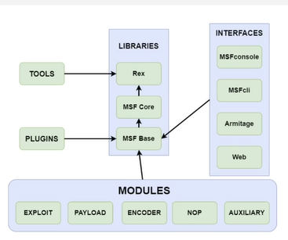
Module: piece of code utilized by msf.
Libraries: facilitate execution of modules without writing the code.

MODULES:
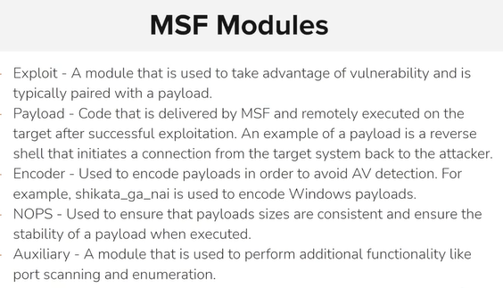

NOPS = No Operation instructions.

PAYLOADS:
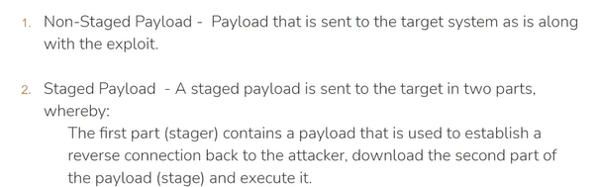

Stagers and stages:
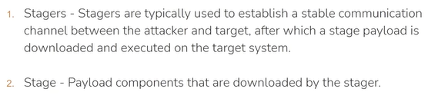
Stage: reverse shell or arbitrary command.

Meterpreter payload:
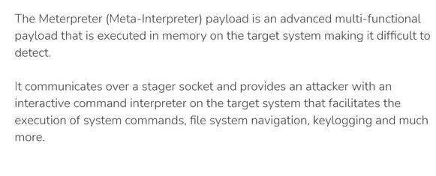
File system structure:
Simple and easy to understand format.
Location:
/usr/share/Metasploit-framework

Modules:
/usr/share/Metasploit-framework/modules

User specific modules/custom Metasploit modules:
~/.ms4/modules

~/ = current user home directory.

DEMO:

/usr/share/Metasploit-framework
# default directory , here the msf stored here.

/usr/share/Metasploit-framework/modules
# they are managed in orders
/usr/share/Metasploit-framework/modules/auxiliary/scanner/smb
# in that they for all the functionalities.

/usr/share/Metasploit-framework/modules/exploits
/usr/share/Metasploit-framework/modules/exploits/linux/mysql

/usr/share/Metasploit-framework/modules/exploits/windows/mssql

How to load custom module:

~/.msf4/modules
# add , sort them , execute them from here.

